Antitheft Telltale CGEA1.3

Functional Description

The purpose of the Antitheft Telltale is to inform the driver of the state of the vehicle security system. (Note: In CGEA, the SPDJB contains all PATS functionality).

The Antitheft_Telltale correlates the Operational_Modeand the ImmoIndicatorCmd signal to illuminate, flash (two possible states), or extinguish the Antitheft_Telltale.

The functionality of this telltale in key off is unique, and will be described here as an overview. When the ignition transitions to OFF/ACC, the telltale will switch to FLASH_OFF flash rate. However, it will still follow the ImmoIndicatorCmd signal if a different value is sent while Door_Ajar_State_Change timer is running. When the Door_Ajar_State_Change timer expires after 35 minutes, the telltale will again switch to FLASH_OFF flash rate. This is to keep the Q-current low. When flashing at the FLASH_OFF rate, the portion of Q-current due to the LED is ~ 1mA. If we were to allow the telltale to remain on soild, that would be ~20mA (thus, the timer).

The Antitheft_Telltale shall provide an iconic representation that will illuminate, flash or extinguish to inform the driver of the status of the vehicle security system.

Interfaces

Interface Context Diagram (I/O Block Diagram)
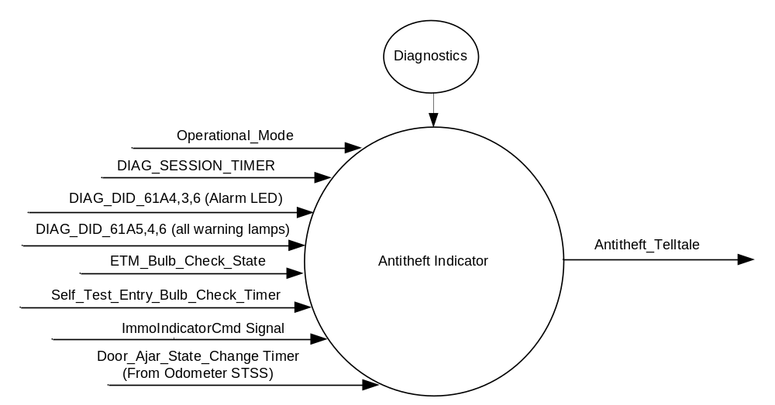
- Antitheft Indication

Inputs

      - INTERNAL:
            - DIAG_SESSION_TIMER
            - Operational_Mode
            - DIAG_DID_61A5,4,6 (all warning lamps)
            - DIAG_DID_61A4,3,6 (Alarm LED)
            - ETM_Bulb_Check_State
            - Self_Test_Entry_Bulb_Check_Timer
            - Door_Ajar_State_Change Timer
- MUX message on the CAN Bus from BCM

- ImmoIndicatorCmd Signal
Signal Name | Size (bits) | Detail | Units | Res. | Offset | State Encoded | Min | Max
ImmoIndicatorCmd | 4 |  | SED | 1 | 0 |  | 0  (0x0) | 3  (0x3)
 |  | OFF |  |  |  | (0x0)
 |  | ON |  |  |  | (0x1)
 |  | Flash_On |  |  |  | (0x2)
 |  | Flash_Off |  |  |  | (0x3)

Outputs
Antitheft_Telltale, which is used to control the state of the LED

Function/Performance

Operational Modes

Mode | Differentiating Vehicle Conditions
Sleep Mode | Antitheft Telltale FLASH at 0.5 Hz
Limited Mode | Antitheft Telltale ON/OFF/FLASH at 4Hz/FLASH at 0.5 Hz
Normal Mode | Antitheft Telltale ON/OFF/FLASH at 4Hz
Crank Mode | Antitheft Telltale ON/OFF/FLASH at 4Hz

Voltage Levels

Refer to the Cluster Features table located in the Operational Modes and Voltage Range Strategies Section in this SPSS.

Human-Machine Interface

Visual

Indicator Graphics / Display Format


For actual symbol definition refer to database TBD of the 03-0685 ARL requirement

Indicator Color Coordinates

Red - Reference SDS IL-0017

Indicator Characteristics

LED - Antitheft Telltale

Audio

None

System Accuracy

The Antitheft_Telltale shall change the state of the Telltale within 100msec of a state change as indicated in the state matrix reference 1.3.5.1 Subsystem Algorithm Flowchart/ State Diagram

Operation: Performance and Functional

Subsystem Algorithm Flowchart / State Diagram

- State Matrix for Antitheft Telltale

Operational_Mode | ETM Bulb_ Check_State | DIAG_  SESSION_  TIMER | Self_Test_ Entry_Bulb_ Check_Timer | DIAG_DID_  61A4,3,6  (Alarm LED) | DIAG_DID_  61A5,4,6  (all warning lamps) | Bulb_  Proveout_  Timer | ImmoIndicatorCmd Signal | Antitheft_ Telltale
Normal or Crank | X | Inactive | X | X | X | Active | X | ON
Normal or Crank | X | Inactive | X | X | X | X | On (0x1) | ON
Normal or Crank | OFF (0x0) | Inactive | Inactive | X | X | Inactive | Flash_On (0x2) | Flash @ 4Hz 50% Duty Cycle
Normal or Crank | OFF (0x0) | Inactive | Inactive | X | X | Inactive | Flash_Off (0x3) | Flash @ .5Hz 50% Duty Cycle
Normal or Crank | X | Inactive | X | X | X | X | Declared missing per SPSS | ON
Normal or Crank | X | Inactive | X | X | X | X | Never Received | ON
Normal or Crank | On(0x1) | Inactive | X | X | X | X | X | ON
Normal | X | Active | Inactive | Not Received | Not Received | Active | X | ON
Normal | X | Active | Inactive | Not Received | Not Received | X | On (0x1) | ON
Normal | OFF (0x0) | Active | Inactive | Not Received | Not Received | Inactive | Flash_On (0x2) | Flash @ 4Hz 50% Duty Cycle
Normal | OFF (0x0) | Active | Inactive | Not Received | Not Received | Inactive | Flash_Off (0x3) | Flash @ .5Hz 50% Duty Cycle
Normal | OFF (0x0) | Active | Inactive | Not Received | Not Received | Inactive | Declared missing per SPSS | ON
Normal | OFF (0x0) | Active | Inactive | Not Received | Not Received | Inactive | Never Received | ON
Normal | ON (0x1) | Active | Not Received | Not Received | Not Received | X | X | ON
Normal | X | Active | X | ON (0x1) | X | X | X | ON
Normal | X | Active | X | X | ON (0x1) | X | X | ON
Normal | X | Active | Active | X | X | X | X | ON
Limited | X | X | X | X | X | X | Not received since transition to Limited | Flash @ .5Hz 50% Duty Cycle
Limited | X | X | X | X | X | X | On (0x1) | ON
Limited | X | X | X | X | X | X | Flash_On (0x2) | Flash @ 4Hz 50% Duty Cycle
Limited | X | X | X | X | X | X | Flash_Off (0x3) | Flash @ .5Hz 50% Duty Cycle
Sleep* | X | X | X | X | X | X | X | Flash @ .5Hz 50% Duty Cycle
All Other Cases |  |  |  |  |  |  |  | OFF

X=Don’t Care
* Note that Door_Ajar_State_Change timer has to expire before the cluster can enter Sleep mode.

Operation Description (supports algorithm flowchart /state diagram)

- The IC shall flash the Antitheft indicator at a rate of 0.5 Hz with a duty cycle of 5% when the Operational Mode transitions from Normal to Limited.
- When in Limited mode and the Door_Ajar_State_Change timer is active, the telltale shall follow the ImmoIndicatorCmd signal.
- When in Limited mode and the Door_Ajar_State_Change timer expires, the IC shall flash the Antitheft indicator at a rate of 0.5 Hz with a duty cycle of 5% and enter Sleep mode as per Operational Modes and Voltage Range Strategies STSS.

Function Safety Classification (EMC)

B

Memory Storage

Parameter Name | Description | Value at  Battery Connect | Value at  Module Wake-up
Antitheft_Telltale | Used to control the state of the LED | OFF (0x0) | OFF (0x0)
DIAG_DID_61A4,3,6 (Alarm LED) | Warning Lamp Status 1, byte 3, bit 6 (Alarm LED) | 0 (0x0) | 0 (0x0)
DIAG_DID_61A5,4,6 (all warning lamps) | Warning Lamp Status 2, byte 4, bit 6 (all warning lamps) | 0 (0x0) | 0 (0x0)
ETM_Bulb_Check_State | State indictator for warning bulb in ETM | OFF (0x0) | OFF (0x0)
Operational_Mode | 4 state indicator for cluster operational mode | Limited | Limited, Normal or Crank

Parameter Name | Description | Value at  Battery Connect | Value at  Module Wake-up
DIAG_SESSION_TIMER | Timer used to time-out a diagnostic session | Not Active | Not Active
Self_Test_Entry_Bulb_Check_ Timer | Timer used in diagnostic session to do a self check of telltales | Not Active | Not Active
Door_Ajar_State_Change Timer | This timer is defined in the odometer STSS. This timer keeps cluster awake for a finite amount of time in limited mode. This timer is used in this STSS as a "failsafe" to guarantee that after 35 minutes the Antitheft tellale will be at the Flash_Off (and thus low Q-current) state. | See Odometer STSS | See Odometer STSS

Prove Out

3.0 +/- 0.1 seconds as per bulb prove out section. Cluster controls proveout. No DTCs shall be logged while Prove Out.

Reconfigurable Telltale

No

Message Center Msg

See Message Center Function

Error Handling

Missing Message Strategy

The signals will be declared missing as per the Diagnostics section of this SPSS.

DTCs states and history will be determined as per the Diagnostics section of this SPSS.

Diagnostics

Self Test

Telltale illuminated during self test as per Self_Entry_Bulb_Check_Timer

Engineering Test Mode

Reference section “Dealer / Engineering Test Mode (ETM)”.

Part II Performance

Supported Diagnostic DIDs (Service $22 and $2F)
Number | DID / CommonID Name | DID Type
61A4 | Warning Lamp Status 1, byte 3, bit 6 (Alarm LED) | Bit Mapped
61A5 | Warning Lamp Status 2, byte 4, bit 6 (all warning lamps) | Bit Mapped

Supported Diagnostic Trouble Codes (DTCs)

DTCs shall be logged as per the diagnostic section of this SPSS.

DTC | Description
C14000 | Lost communication with Body Control Module (BCM).

Reference Specification

IS-0001 WARNINGS/INDICATORS/DISPLAYS PROVEOUT
IS-0046 INSTRUMENTATION MATERIAL RESISTANCE TO CLEANING
IS-0052 OPERATING VOLTAGES - FUNCTIONAL/PERFORMANCE
IS-0069 FUNCTIONAL IMPORTANCE CLASS
IS-0324 WINDSHIELD & OTHER REFLECTIONS
IS-0327 WARNING INDICATOR EVALUATION
IS-0329 FLICKERING OF LAMPS

IL-0017 TELLTALE AND INTERIOR ILLUMINATION COLOR
IL-0021 CRAFTSMANSHIP - DISPLAYS
IL-0023 CLARITY/LEGIBILITY/READABILITY
IL-0025 INTERIOR ILLUMINATION INTENSITY
IL -0027 VISUAL CONTRAST
IL -0043 OPERATIONAL ENVIRONMENT FUNCTIONALITY
IL -0045 COLOR
IL -0047 TELLTALE; INDICATOR AND DISPLAY LIGHT INTENSITY
IL -0048 ILLUMINATION ACCEPTABILITY

03-0661 PLACEMENT: CONTROL AND DISPLAY LOCATIONS
03-0662 PLACEMENT: LOGICAL GROUPING FUNCTION AND USAGE
03-0664 PLACEMENT: DOWN VISION TO COMPONENTS WITH HIGH VISUAL DEMAND
03-0665 PLACEMENT: EXPECTED LOCATIONS OF CONTROLS AND DISPLAYS VDS
03-0670 INTERIOR VISIBILITY
03-0671 INTERIOR VISIBILITY: REFLECTIONS FROM COMPONENTS & SURFACES
03-0672 INTERIOR VISIBILITY: REFLECTIONS IN DISPLAYS
03-0673 INTERIOR VISIBILITY: VISUAL OBSCURATIONS
03-0674 INTERIOR VISIBILITY: ILLUMINATION CONTROLS / DISPLAYS
03-0675 INTERIOR VISIBILITY: VEILING GLARE
03-0677 INTERIOR VISIBILITY: SUNLIGHT WASHOUT
03-0681 IDENTIFICATION: CHARACTER AND SYMBOL SIZE
03-0682 IDENTIFICATION: LEGIBILITY
03-0685 IDENTIFICATION: SYMBOLS, ABBREV FOR CONTROL
03-0721 LOGIC OF OPERATION: OPERATIONAL STEREOTYPES
03-0722 LOGIC OF OPERATION: INTERPRETATION
03-0723 LOGIC OF OPERATION: USE OF SYSTEMS WITH VISUAL DISPLAYS

Revision History

SPSS Module Revision History

Revision Level | Name | Change Description | Date
1.0 | V. Patel | Updated for CGEA 1.3 based on CGEA STSS v1.1  Section 1.2.2 – Deleted table referencing the HS-CAN message that contains the input signal. Deleted “ID” and “POS” columns from table 1.0  Table 1.1 – Changed wording from “Missing as per 1.4.1” to “Declared missing per SPSS” where applicable.  Section 1.4 – Rewritten. Deleted references of specific missing message flags and timer.  Section 1.5.3 – DTC logging criteria from table. | 3/26/2010

